NAME: VILLAFLOR, JAMES DARRYL I.

BSIT-3K

# Activity #3 HTTP Requests - Use and Run Codes

* **Making HTTP GET Requests in PHP**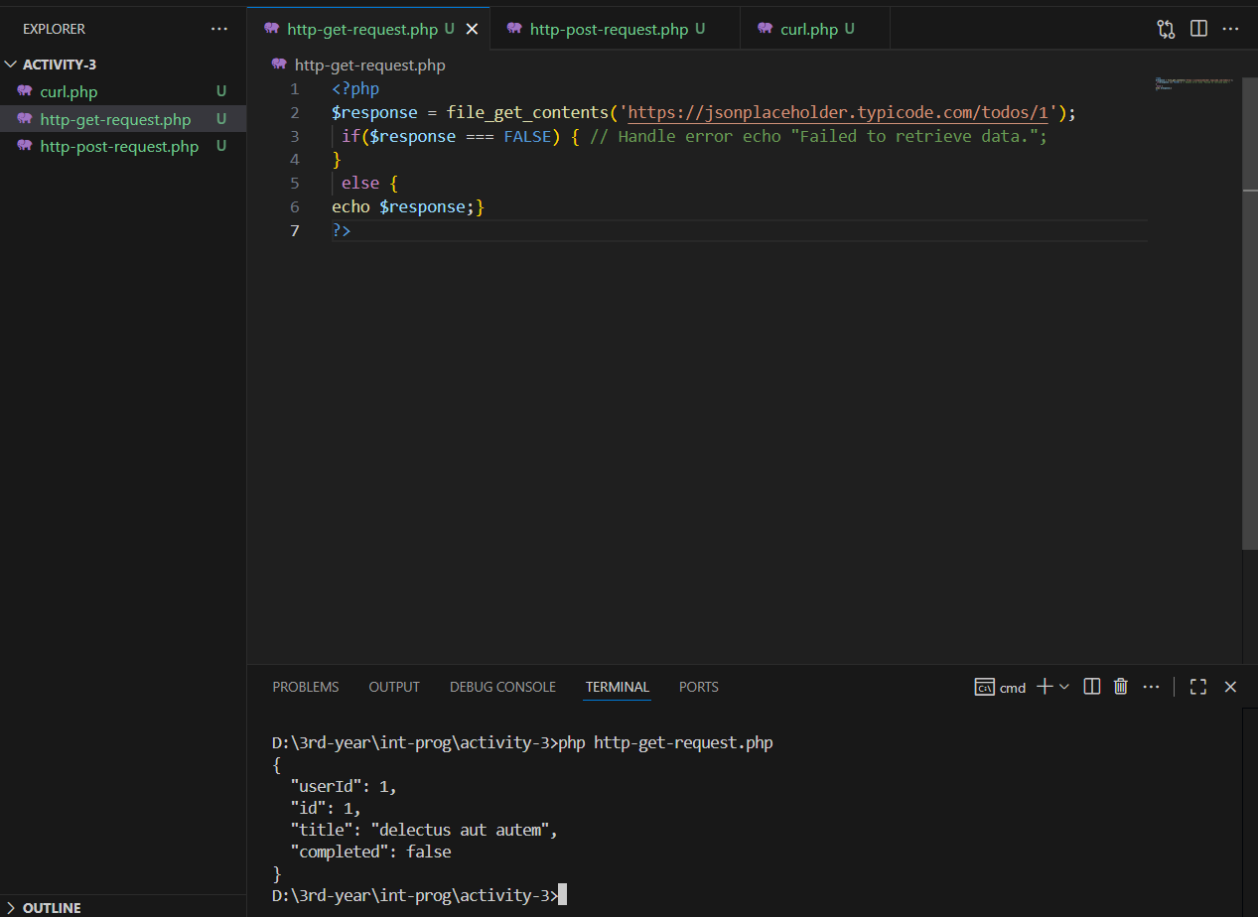
* **Making HTTP POST Requests in PHP**

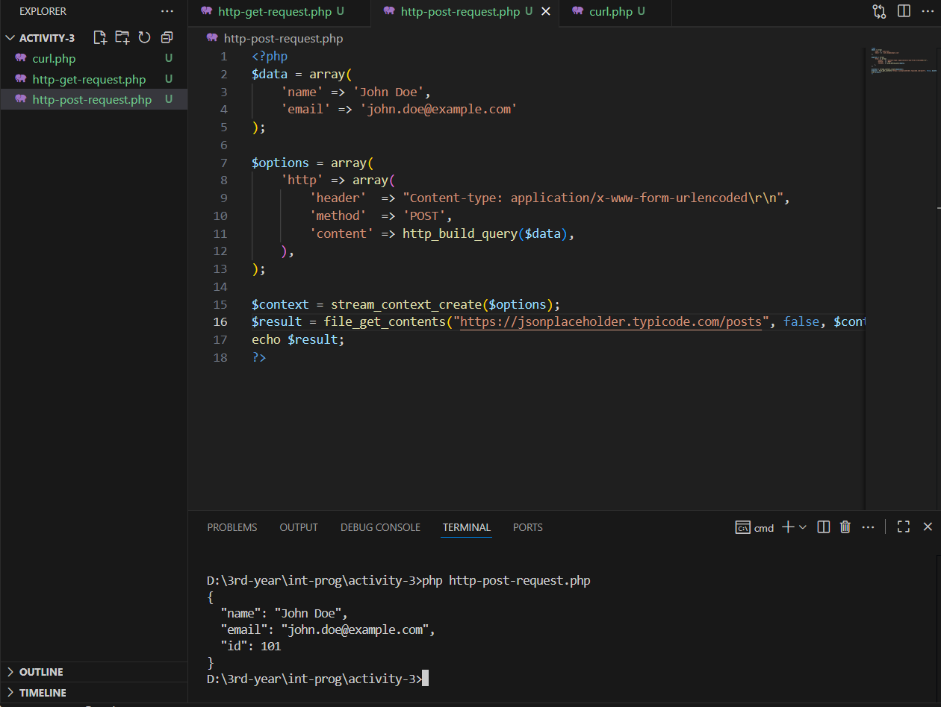

* **Using cURL for Robust HTTP Requests**

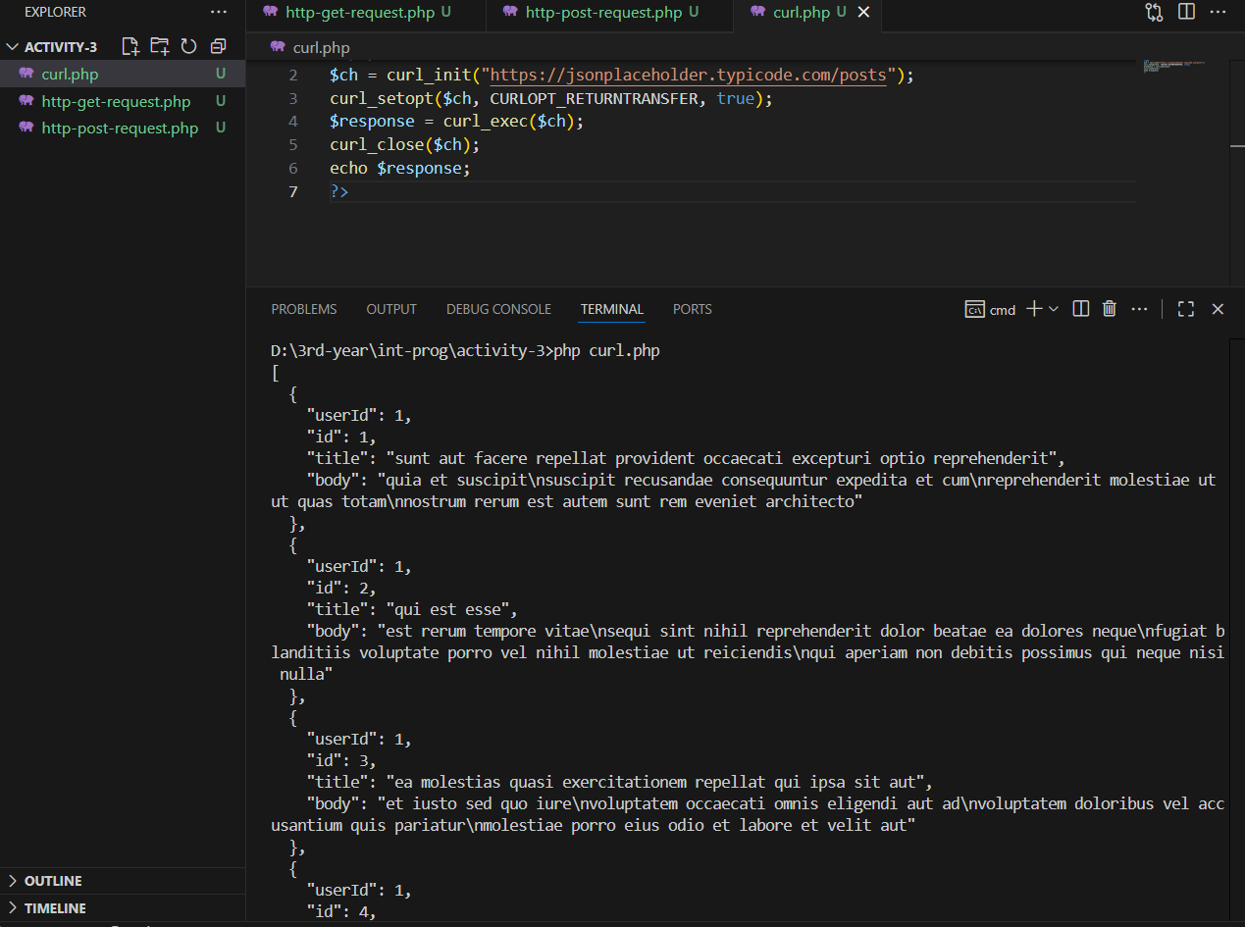

* **Working with HTTP Headers in PHP**

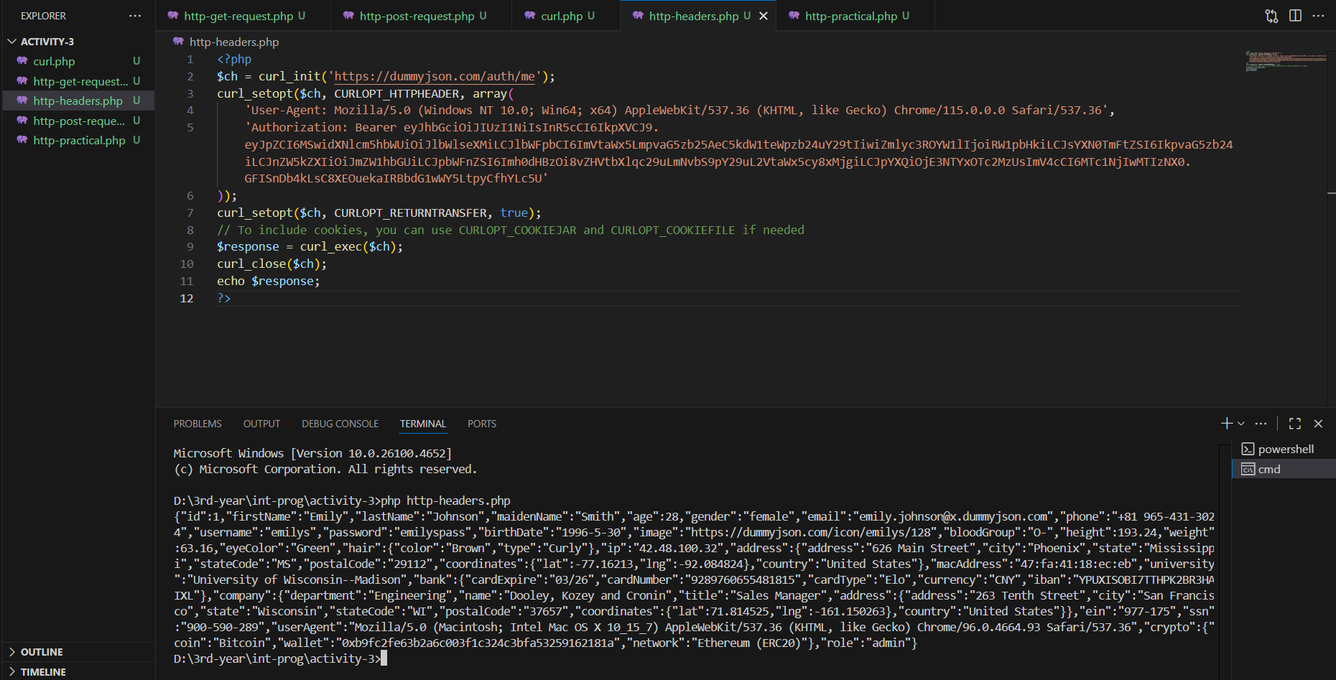

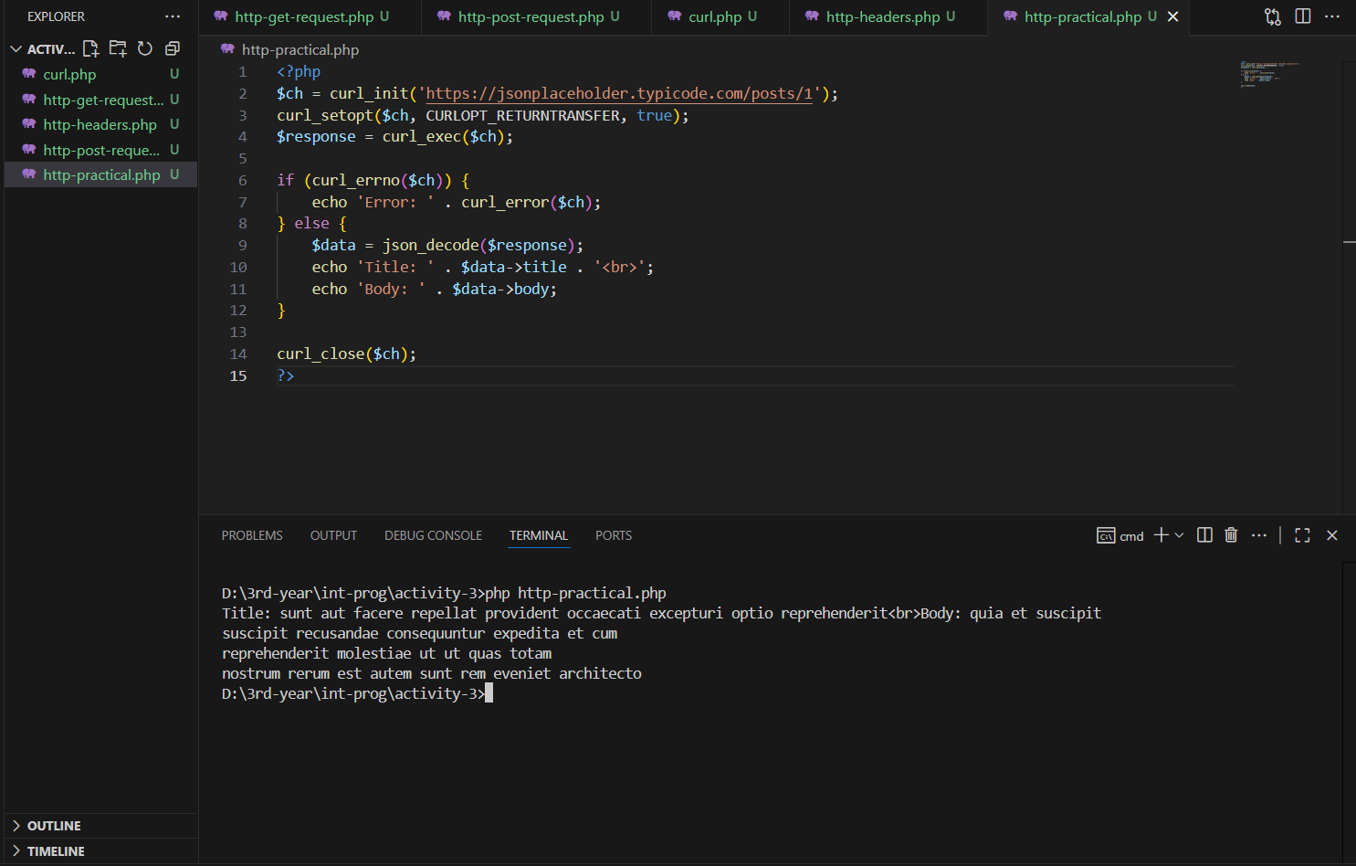

* **Practical Example: Consuming a REST API**